**Assignment: UML Design**

**CPSY 301**

**Software Projects: Analysis, Design and Management**

Prepared for Arta Farahmand

Prepared by:

Savanna Piscitelli | Theodore Wells | Elvis Chizoba | James Bareng

Students of Software Development Diploma at

Southern Institute of Technology

Contents

Use Case Diagram 3

Use Case Description 4

Class Diagram 5

Class Diagram Entity description 6

Sequence Diagram 7

User Log In (Sequence Diagram) 7

User Log in (case scenario description) 7

System Arm / Disarm (Sequence Diagram) 8

State Diagram 9

State Diagram Description 9

Glossary 10

# Use Case Diagram

|  |  |
| --- | --- |
| **Use Case** | **Description** |
| Log In from the Internet | Household users will be given access to their alarm system as long as they have a secure internet connection. |
| Set Alarm | This feature is reserved for the household users on how to set their alarm system. |
| Turn up/down air conditioning | This feature will allow the household user to set the desired temperature of their house. They must also have a secure connection to the internet to access this feature. |
| Monitor security zones/sensors | Monitoring different zones and sensors will tell the household users which windows/doors are open before they’re able to arm and or disarm the system. This will provide the status of each sensor whether they’re in good operating condition or if a battery needs to be replaced. |
| Arm/Disarm Security System | User interacts with device to set alarm system to either arm state or disarmed state. This will require the user to have a valid username and password. The configuration manager will not be able to access this feature as they should not have a valid username and password. |
| Record/play back captured videos or events | Household users will have access to the alarm system’s memory of events that were recorded. They should have an option to either delete or export their files for their needs. |
| Reconfigure Security Zones/Sensors - | This feature is exclusive for the household user to select how they Reconfigure the system after it was initially configured by the installer or configuration manager. |
| Access cameras | Household users will also have access to live streaming the camera from anywhere if they have access to the internet. This will also require them to use a valid username and password for authentication. |
| Block camera access | This feature is to allow the household users to set which cameras other household users should have access to. |
| Add/Remove Devices | This role is for the configuration manager to add and remove devices to meet client’s needs for the system. This includes programming the devices for clients to interact with from the alarm system. |
| Change Codes | The configuration manager will have access to initialize the system and change activation codes for the system. |
| Layout Configuration | The configuration manager will be able to configure the system according to the house's layout and where the system sensors are located within the system's perimeter. |

## Use Case Description

# Class Diagram

This class diagram is a representation of the relationships and interactions among various entities within the alarm system. Each class is represented as a rectangle and symbolizes an entity or object that contains its core attributes and behaviors. The lines and symbols connecting the rectangles represents their associations, inheritance aggregations and compositions that represents their relationship to other entities.

## Class Diagram Entity description

|  |  |
| --- | --- |
| **Class Name** | **Description** |
| Web Browser | Web browser entity contains several methods for the household user to access their account and alarm system. This representation will provide online access from anywhere around the world. |
| Control Panel | Control panel will provide the household user access to manipulate the system at the premise and will have default functions to arm and disarm the system. |
| Central Processor | Central processor will provide the logical methods to validate user access and privileges to the system. This also bridges the digital interface to analog (system's physical sensors and detectors). |
| Actuator | This part of the system will utilize their specific capabilities to implement the commands coming from the central processor such as monitor, ignore, and trigger the alarm etc. |
| Sensor | Devices that detect changes in the environment, such as motion, open doors/windows, fires, etc., and send this information to the central processor. |
| Household User | Homeowner or resident who can arm, disarm, and set activation codes for the security system using the control panel or web browser. |
| Corporate Web Browser | Online interface for users who are away from home, allowing them to access and control their security system via the Safe Home corporate website. This would also give the users more information about the company and their products and services |

# Sequence Diagram

## User Log In (Sequence Diagram)

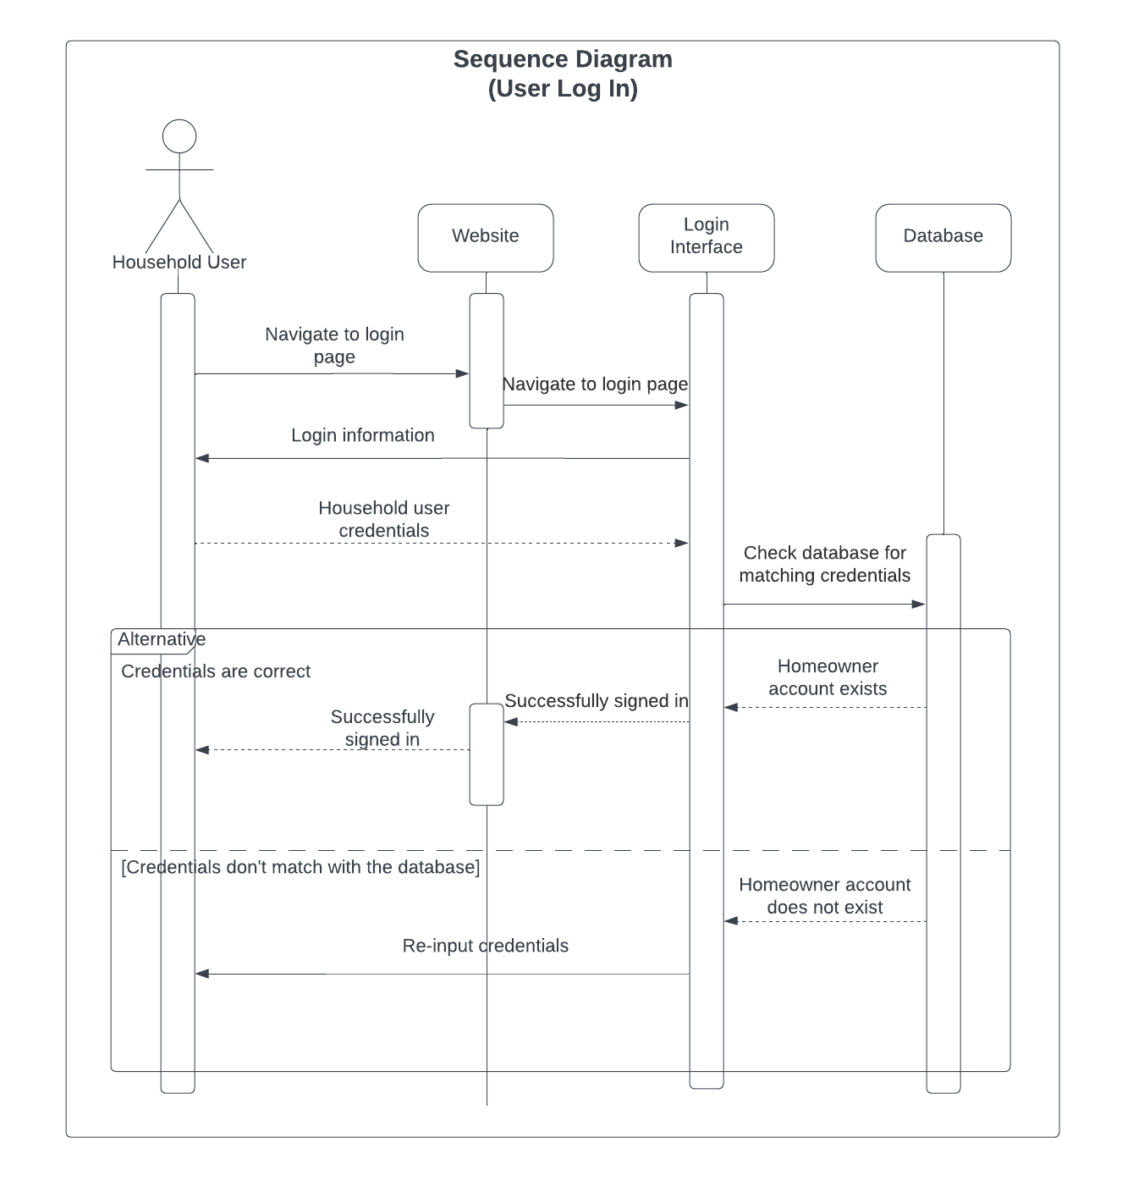

## User Log in (case scenario description)

The Household User, representing the homeowner or resident, initiates the login process to access their security system. This process begins when the user navigates to the website's login page. The website provides a login interface where the user is prompted to enter their login details, typically a username and password.

Once entered, these credentials, referred to as the Household User Credentials, are transmitted to the system for verification. The system then performs a database action to check if the provided credentials match any existing homeowner accounts.

If a match is found, indicating the homeowner account exists, the user is successfully signed in and gains control over the security system. However, if there's no match, suggesting the homeowner account does not exist or the credentials are incorrect, the system notifies the user. In such instances, they might be prompted to re-enter their credentials for another attempt.

## System Arm / Disarm (Sequence Diagram)

The "Arm/Disarm" sequence diagram shows how a household user, such as a homeowner, interacts with the security system to arm or disarm it. The Control Panel, which serves as the primary interface through which the user controls the system, serves as the focal point of this interaction. Sensors, which keep an eye on environmental changes like motion or open doors, are essential to the system.

The user enters an activation code into the Control Panel to manage the security measures. Access is given and the user has the option to arm the sensors if this code matches one that is already saved. The Control Panel responds by giving a confirmation message once you do this. The Control Panel will once more validate the activity if the user elects to disable the sensors.

However, the system indicates this discrepancy if the activation code entered doesn't match. The user is given another opportunity to enter the right code after that. If they fail once more, the machine stays in its pre-armed default state, and the user is unable to arm it.

This diagram essentially shows how a homeowner works with the Control Panel and Sensors of the security system to activate or deactivate the security features, with backup plans in place for incorrect code entries.

# State Diagram

## State Diagram Description

The State Diagram for a Security System shows the different configurations that the system can take, including Disarmed, Armed, and Alarmed, as well as the precise transitions between each configuration. A Disarmed State is typically selected when the user wants the security system to remain dormant since it renders the security system inert and ignores any movement that the sensors detect. When in this mode, the system can go immediately to an Alarmed state if an incursion is detected while it is disarmed or to an Armed state if the user chooses to activate it.

When the system is armed, it is on alert and aggressively scanning through the sensors for any potential intruders. Any detected intrusion in this Armed state leads the system to go to the Alarmed state. Here, the security system detects a breach and starts several reactionary measures, including blaring alarms, notifying authorities, and turning on surveillance cameras. Additionally, the user has the option to press a panic button in an emergency to activate security features right away or call for help. This is a special action that the user can perform to instantly activate the alarm and call for assistance right away or activate emergency security measures.

The state diagram describes how a security system functions and switches between its different operational states—Disarmed, Armed, and Alarmed—and how that system transitions between those states.

# Glossary

|  |  |
| --- | --- |
| **Class Diagram** | A type of diagram in object-oriented design which illustrates the structure of a system by showing the system's classes, their attributes, operations (or methods), and the relationships among objects. |
| **Relationships** | Connections or associations between two or more entities. |
| **Interactions** | The ways in which entities affect or communicate with one another. |
| **Entities** | Anything that has a distinct and separate existence, typically used in software design to refer to objects or components. |
| **Rectangle** | A shape used in the class diagram to represent a class or entity. |
| **Attributes** | Characteristics or properties of an entity. |
| **Behaviors** | Actions or methods that an entity can perform. |
| **Associations** | The way in which two or more entities are connected or related in the context of the class diagram. |
| **Inheritance** | A mechanism where a new class is derived from an existing class, inheriting its attributes and behaviors. |
| **Aggregations** | A type of association which represents a whole-part relationship. For example, a car (whole) can be aggregated from an engine, wheels, and doors (parts). |
| **Compositions** | A stricter form of aggregation where the part entities cannot exist independently of the whole. If the whole is destroyed, so are its parts. |
| **Household User** | Refers to an individual, such as a homeowner, who uses and interacts with a residential security system. |
| **Security System** | An arrangement of interconnected components used for security purposes, such as detecting intruders or monitoring environmental changes in a property. |
| **Control Panel** | The primary interface or dashboard through which users manage and control the security system. |
| **Sensors** | Devices that detect and respond to specific environmental changes, such as motion or the opening of doors and windows. |
| **Activation Code** | A unique set of digits or characters that users input into the Control Panel to authenticate their access and manage the security system. |
| **Validate** | The process of checking or verifying user input or actions to ensure they are correct and authorized. |
| **Discrepancy** | A divergence or inconsistency, in this context referring to a mismatch between the entered activation code and the one stored in the system. |
| **Configurations** | The specific states or conditions in which the security system can exist, such as disarmed, armed, or alarmed. |
| **Disarmed State** | A configuration in which the security system is deactivated, making it unresponsive to potential threats detected by the sensors. |
| **Armed State** | A configuration where the security system is active, monitoring for potential threats and ready to react if one is detected. |
| **Alarmed State** | A reactive state triggered when the security system detects a security breach, initiating several protective actions. |
| **Transitions** | The shifts or changes from one configuration or state to another based on specific conditions or triggers. |
| **Intrusion/Incursion** | Unauthorized entry or invasion, indicating a potential security breach. |
| **Reactionary Measures** | Actions initiated by the security system in response to a detected security threat. |
| **Panic Button** | A feature allowing users to instantly trigger the alarm and activate specific emergency measures in the event of a perceived immediate threat. |
| **Surveillance Cameras** | Devices used to visually monitor and record areas for security purposes. |
| **Notifying Authorities** | Alerting local law enforcement or security services about a potential or confirmed security breach. |